Name: Mrs. Rupali N Hosmani.

Course: Executive Post Graduate Certification in Cloud Computing

Contact No. 7720003531

**Assignment 8: Database Services**

**Tasks To Be Performed:**

**A]**

1. Create a MariaDB Engine based RDS Database.

2. Connect to the DB using the following ways: a. SQL Client for Windows b. Linux based EC2 Instance.

**B]**

1. Create an AuroraDB Engine based RDS Database.

2. Create 2 Read Replicas in different availability zones for better infrastructure availability.

**C]**

1. Create a DynamoDB table with partition key as ID.

2. Add 5 items to the DynamoDB table.

3. Take backup and delete the table.

**D]**

1. Create a Redshift data warehouse.

2. Using the query editor: a. Load some data b. Query the data.

**Steps to be performed:**

**A]**

1. For Creating a MariaDB Engine based RDS Database go to AWS RDS service .

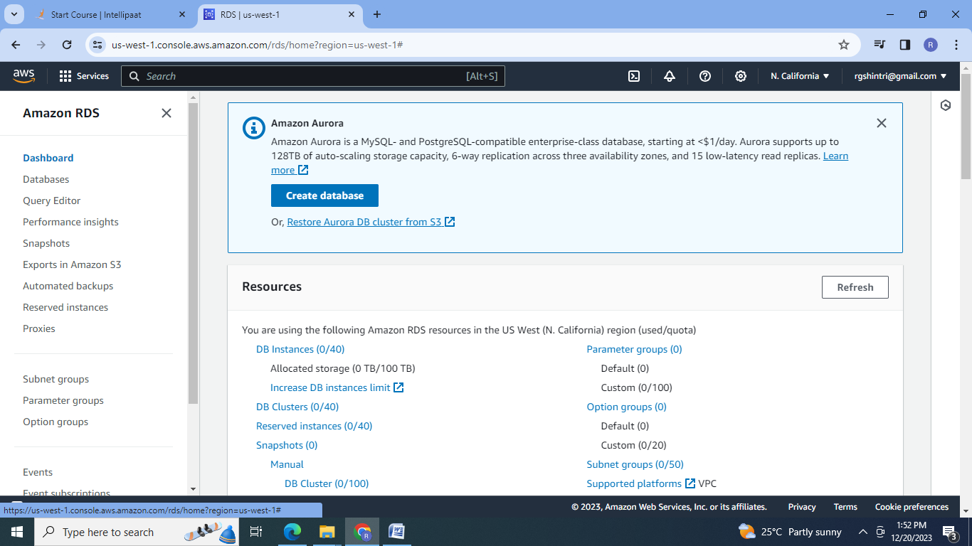

2.Create RDS instance with MariaDB engine:

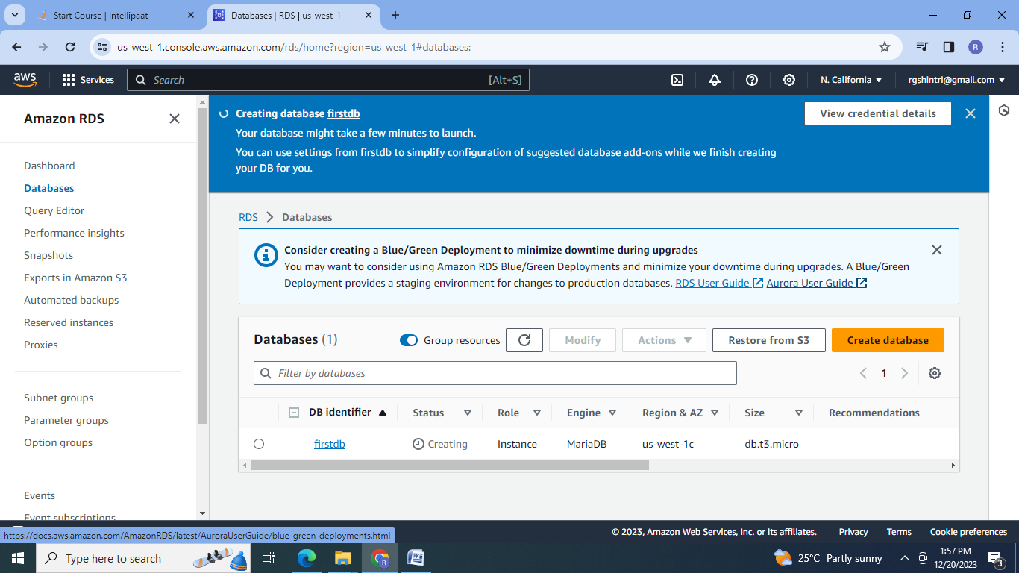

3.RDS Instance with MariaDB Engine is created:

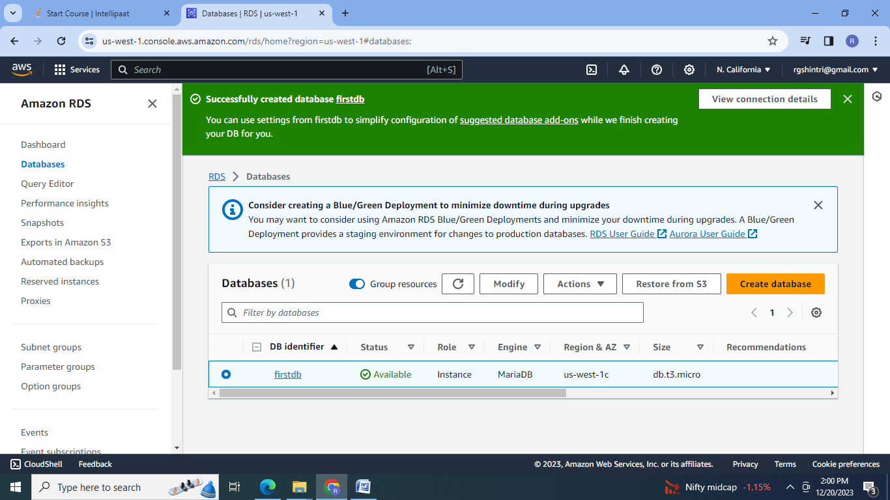

4.Database configuration:

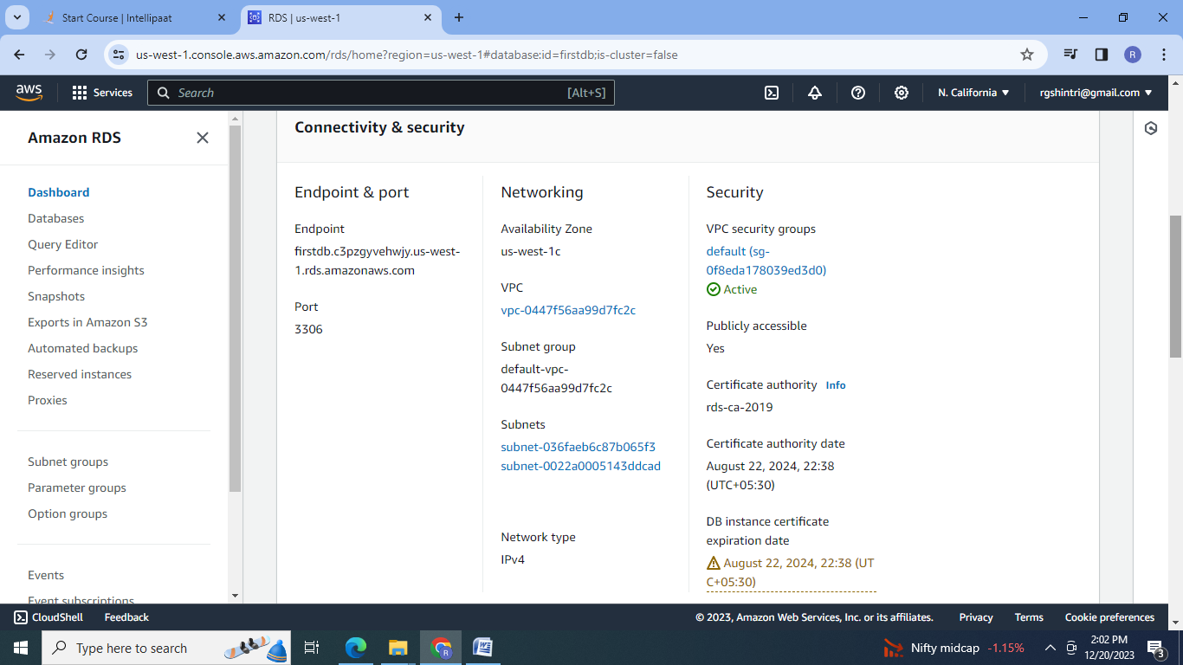

5.Connect to the DB using the following ways: a. SQL Client for Windows:

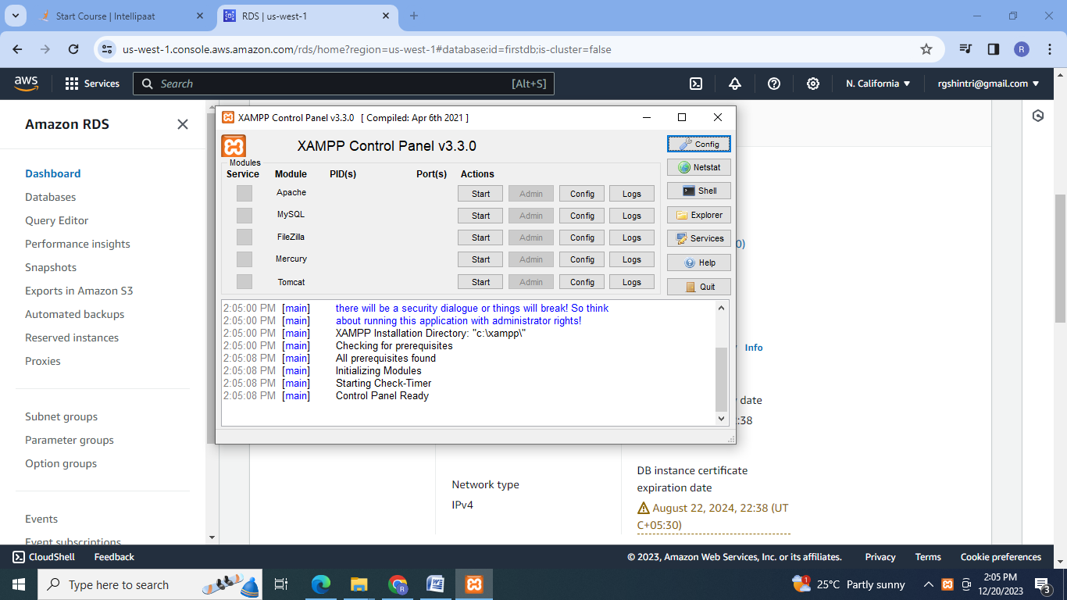

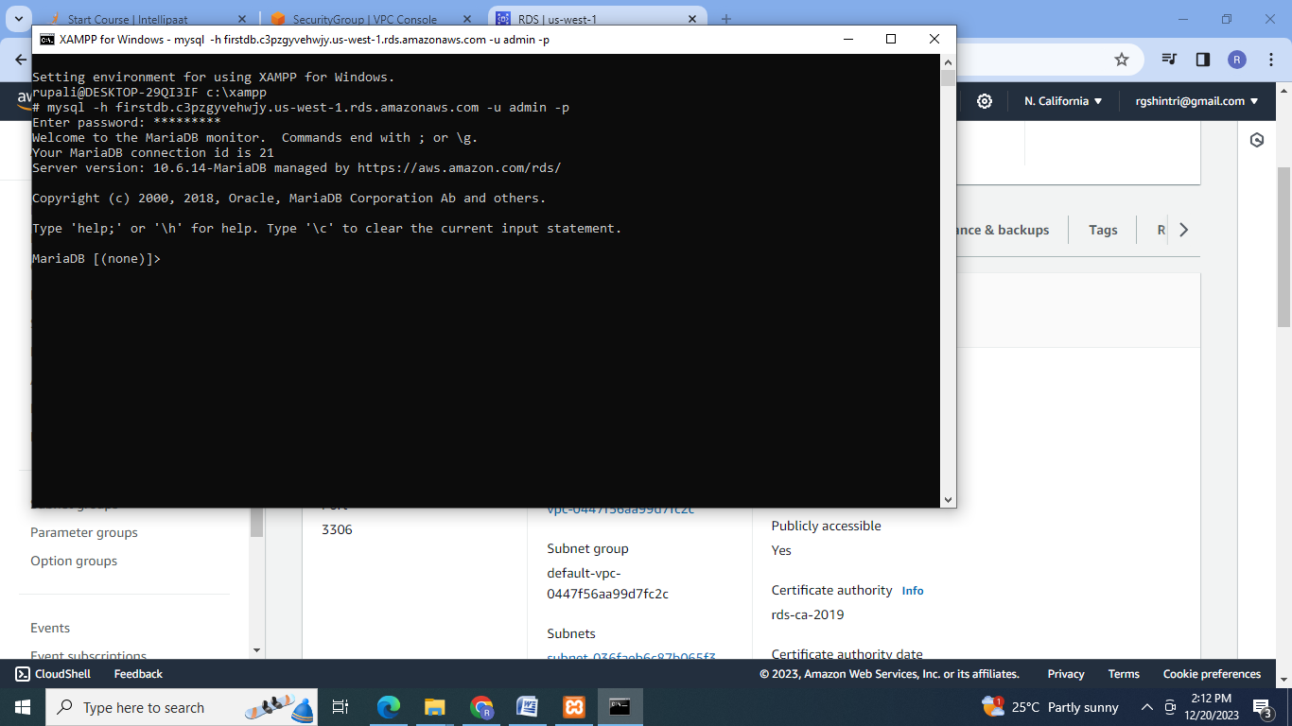

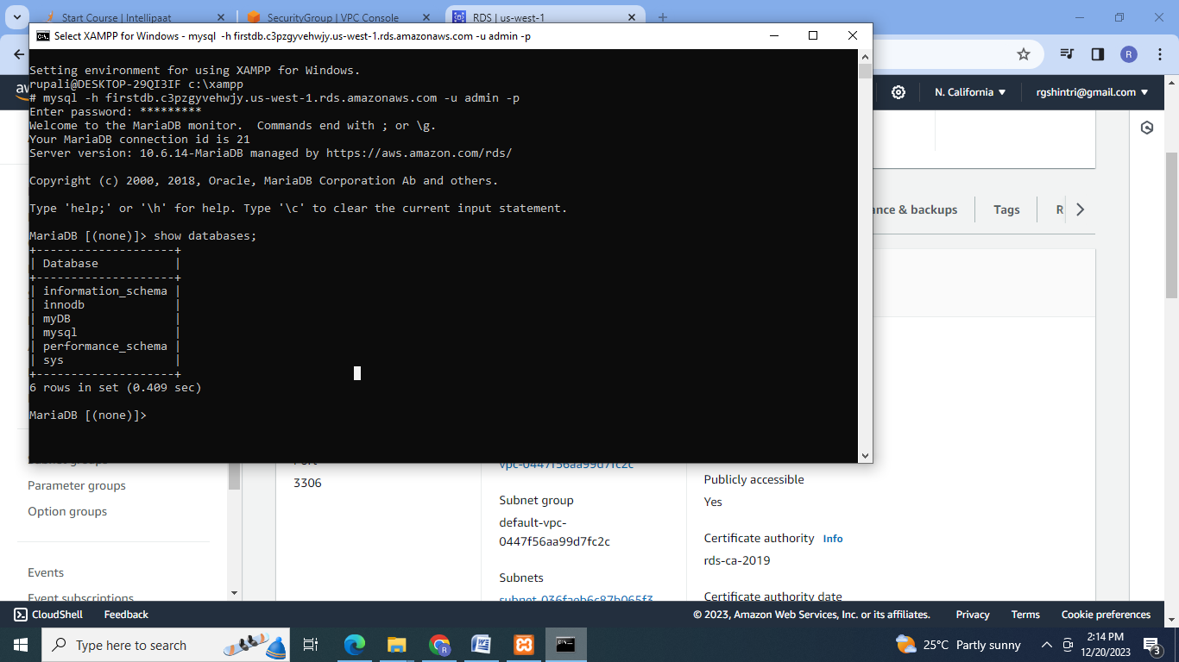

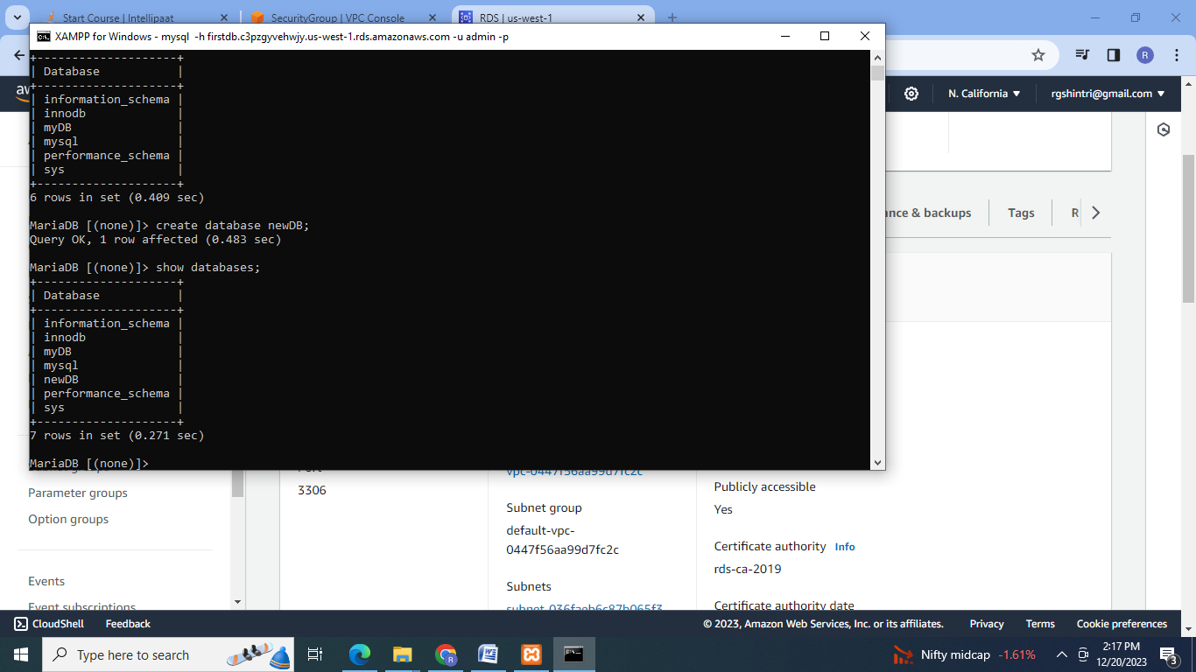

6. Connect to the DB using the linux based EC2 instance

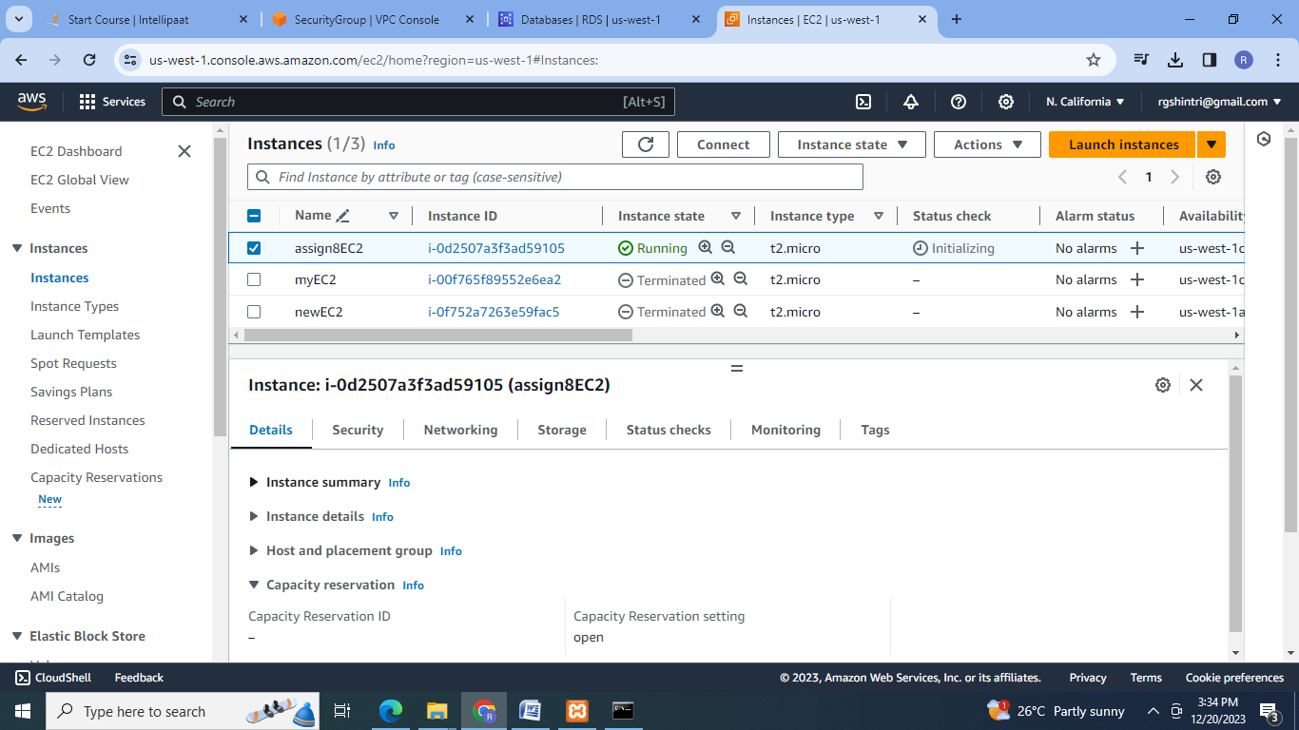

7. Connect to the database:

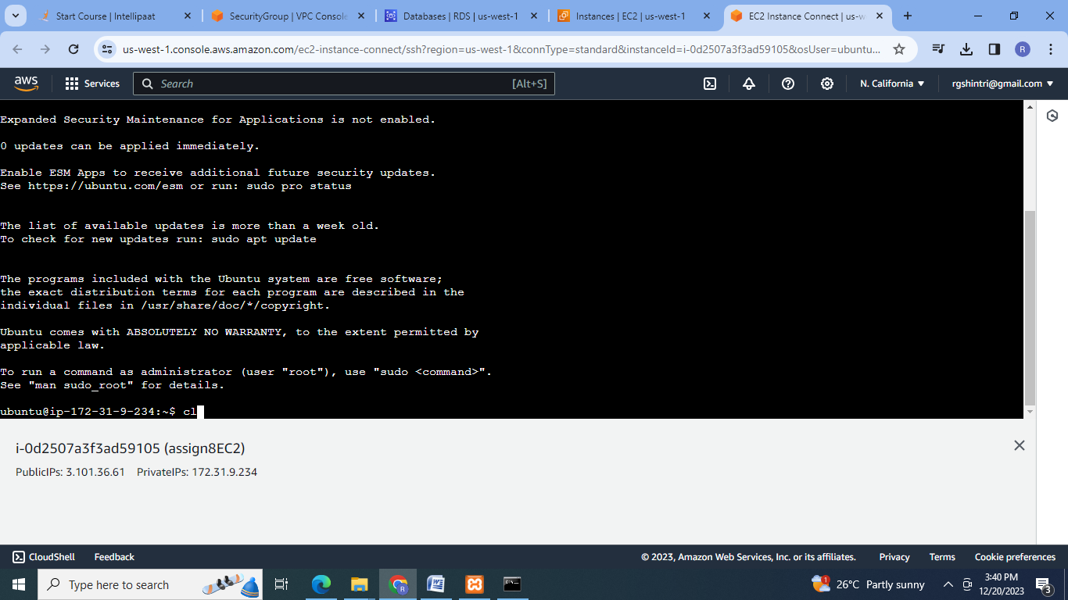

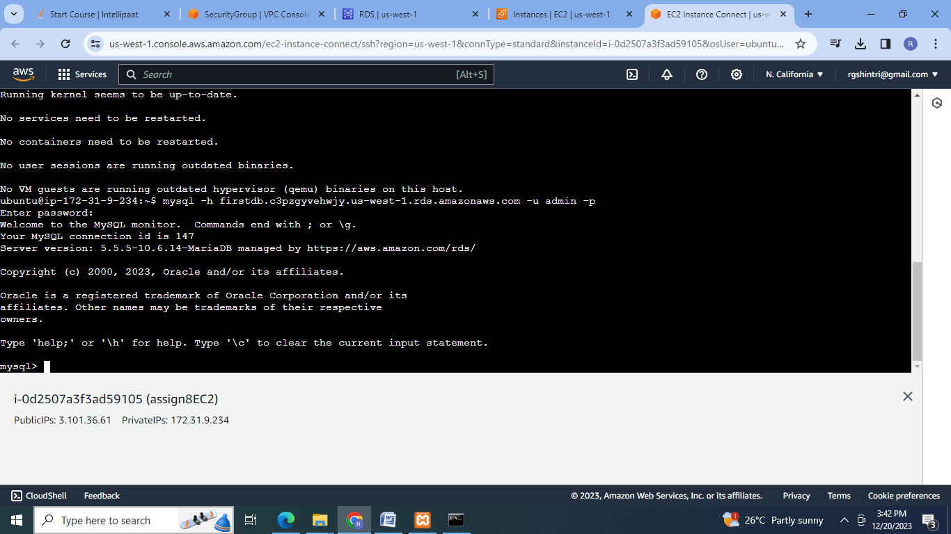

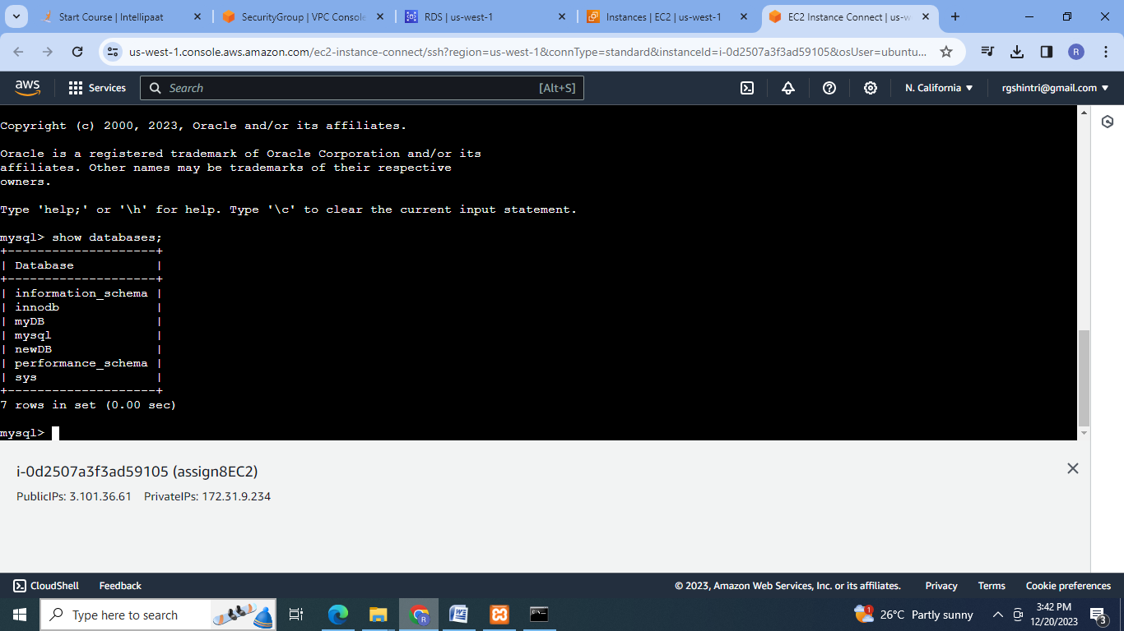

8.Create the new database:

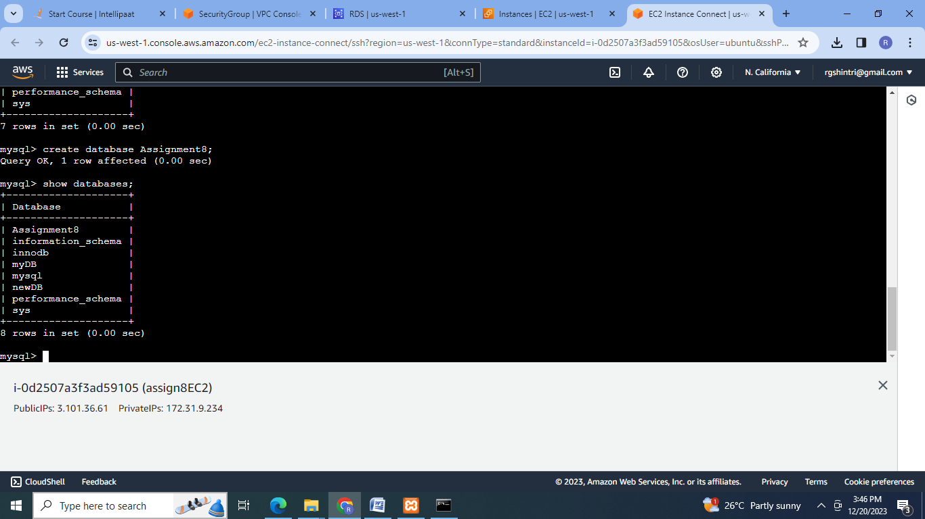

**B]**

1. Create an AuroraDB Engine based RDS Database.

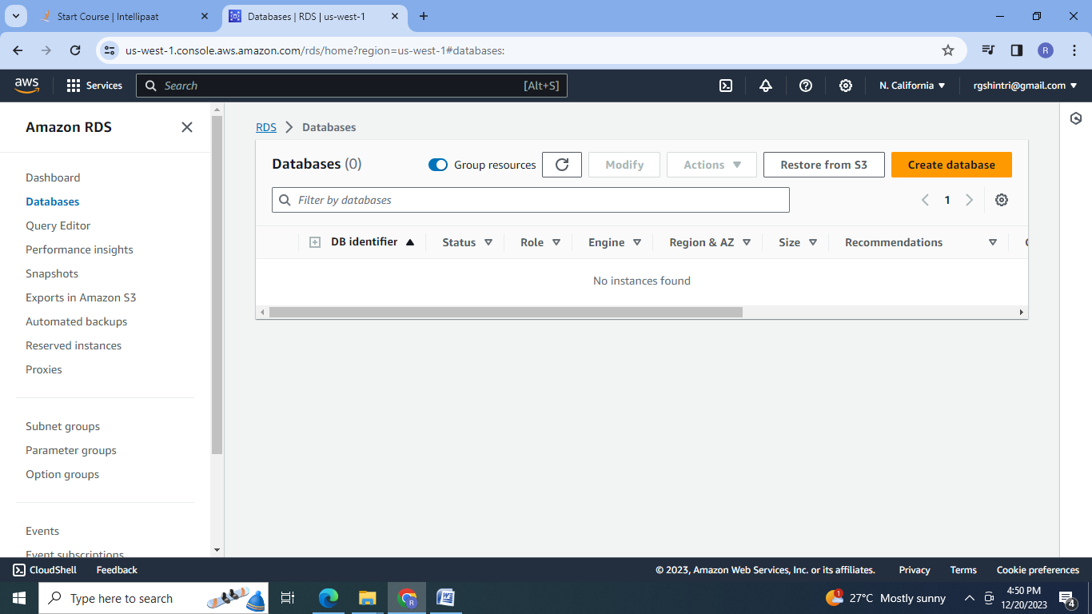

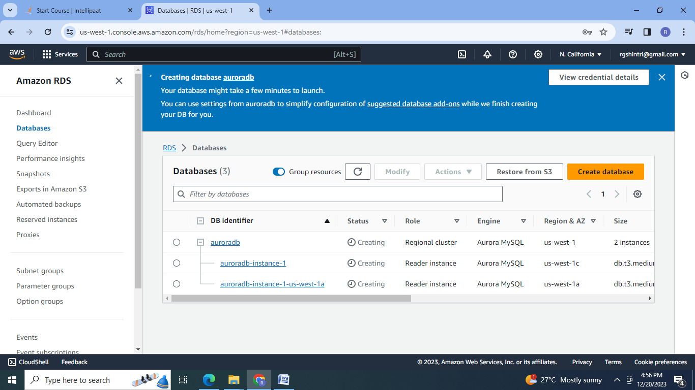

2. RDS instance with AuroraDB engine is created:

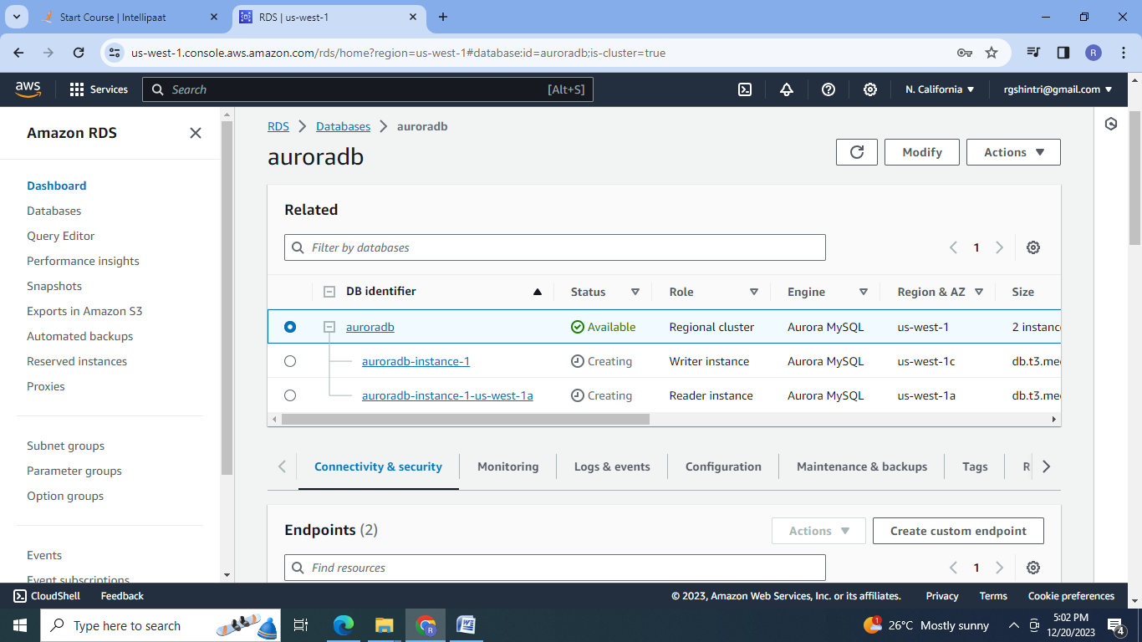

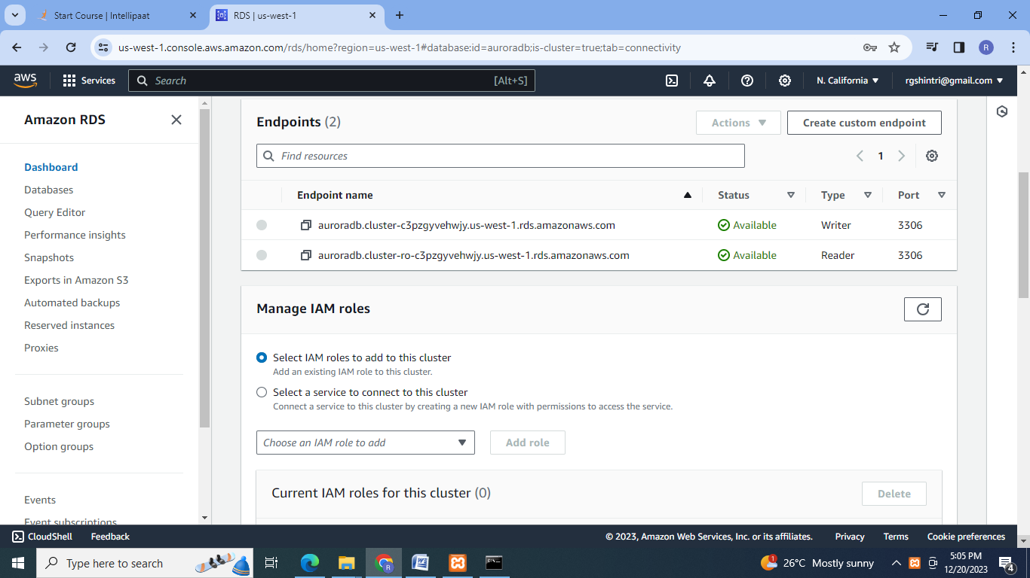

3.Connect to the database:

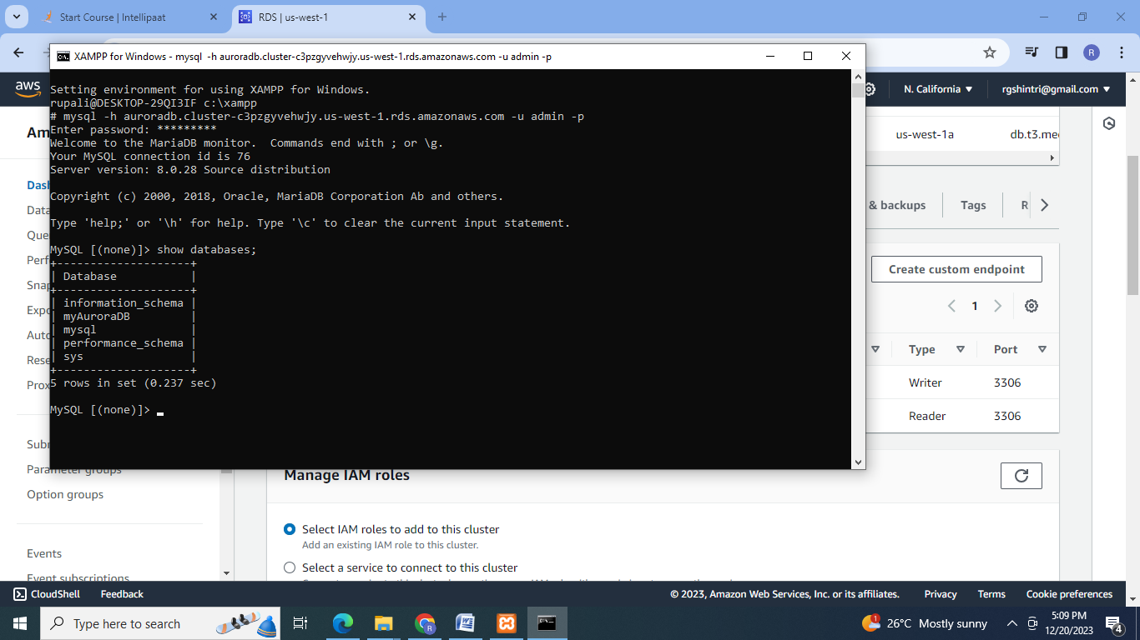

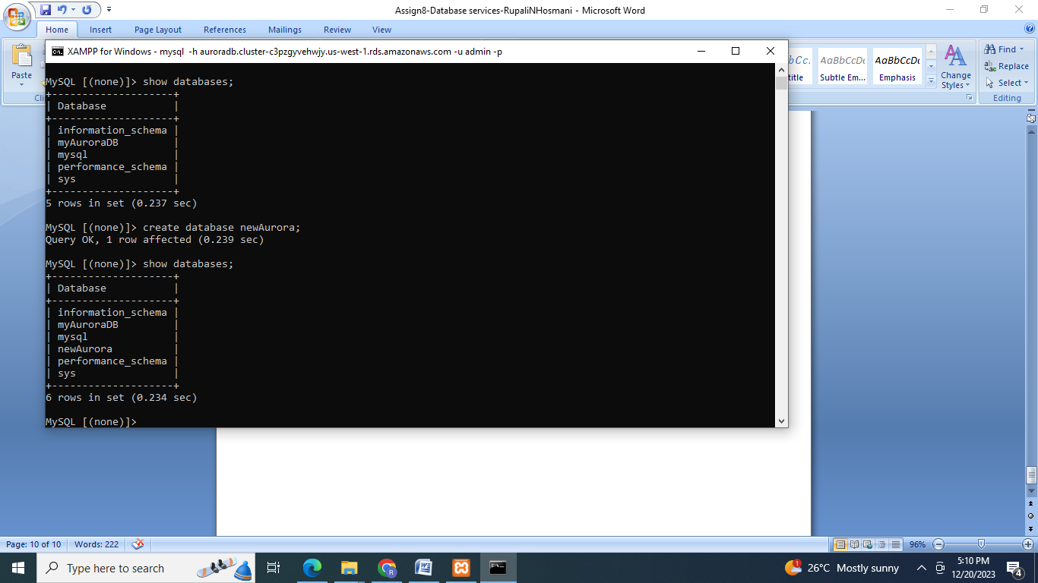

4. Create 2 Read Replicas in different availability zones for better infrastructure availability.

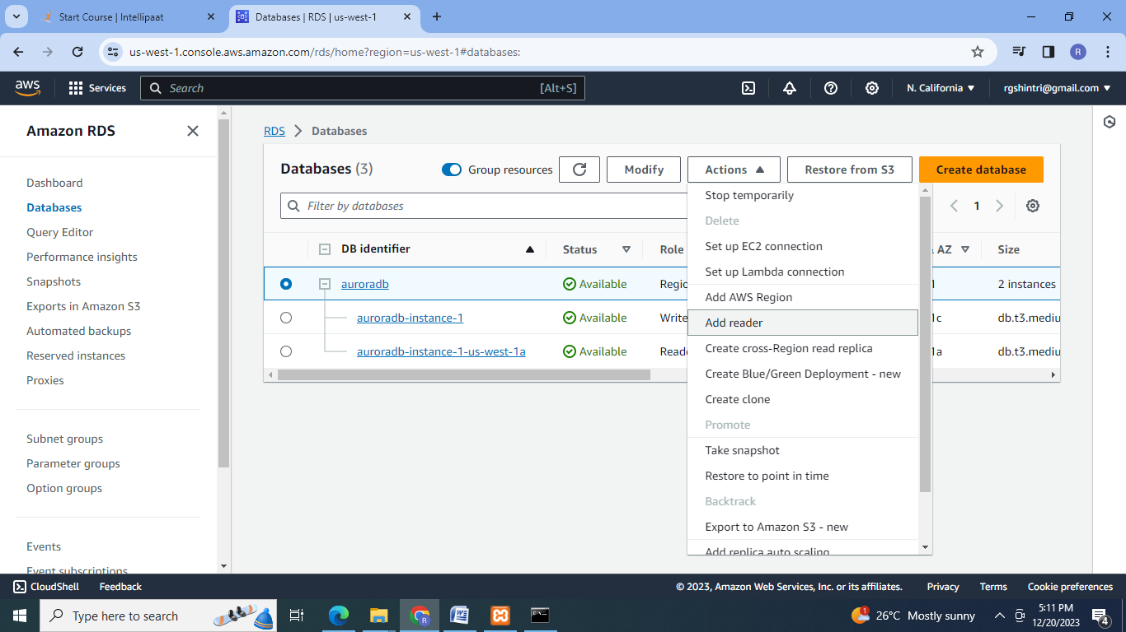

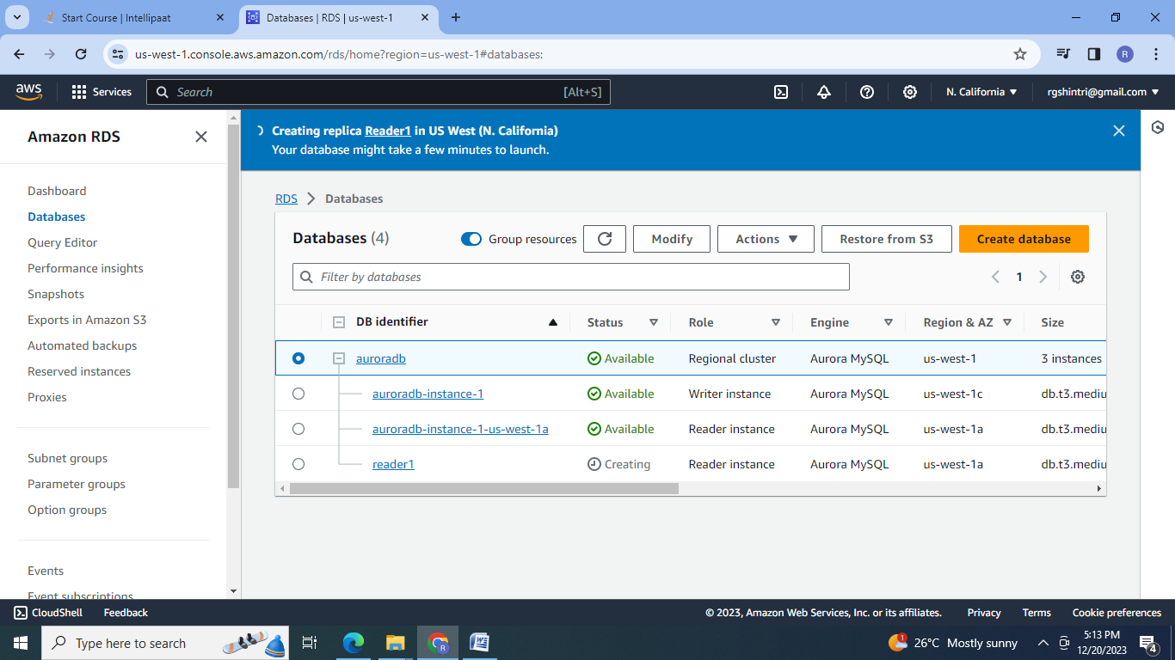

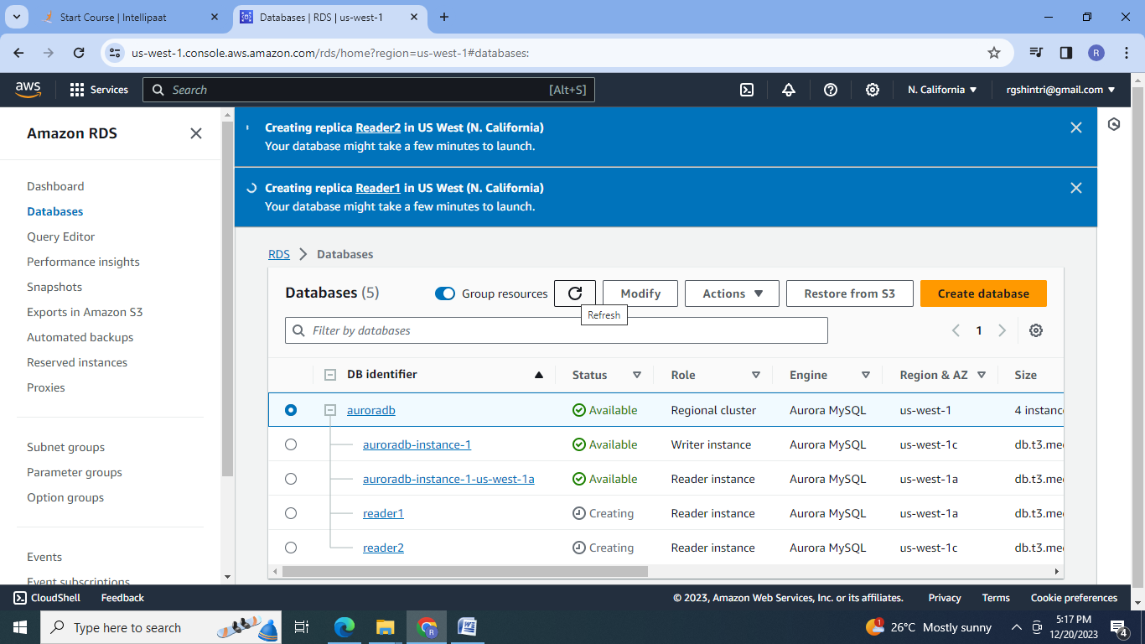

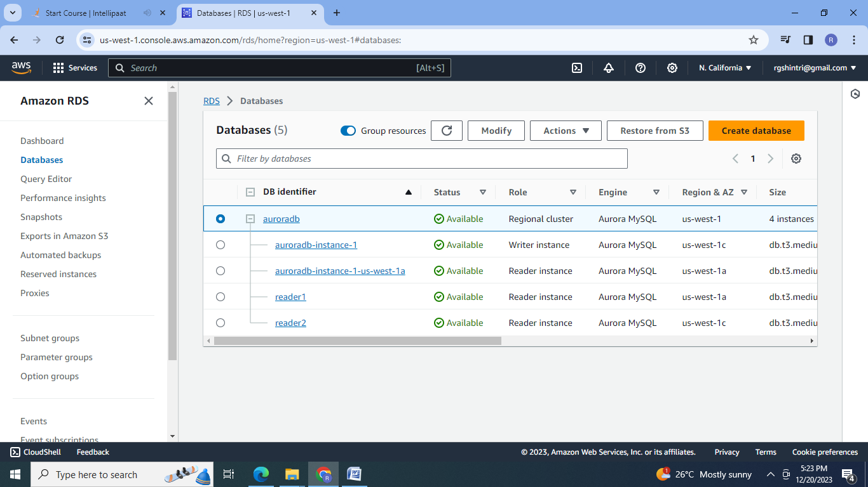

**C]**

1. Create a DynamoDB table with partition key as ID.

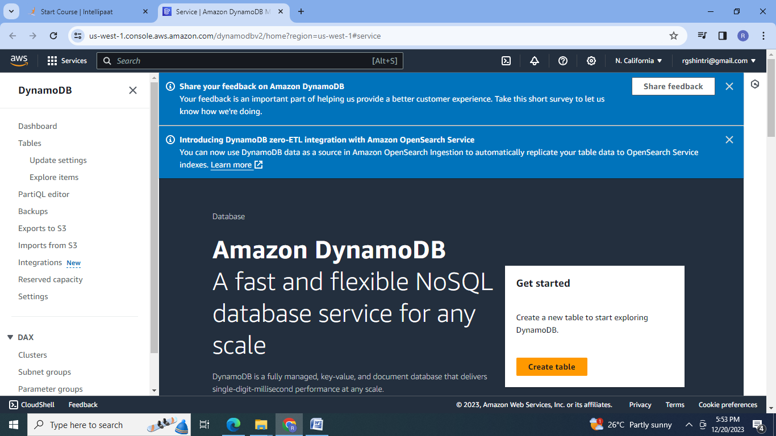

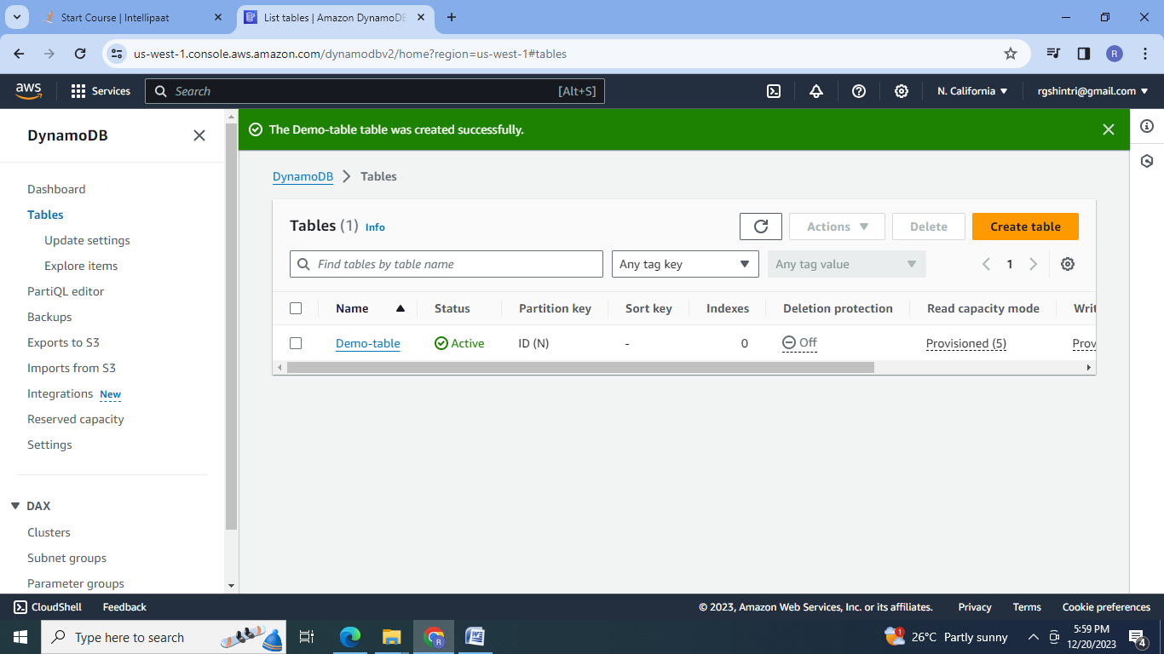

2. Add 5 items to the DynamoDB table:

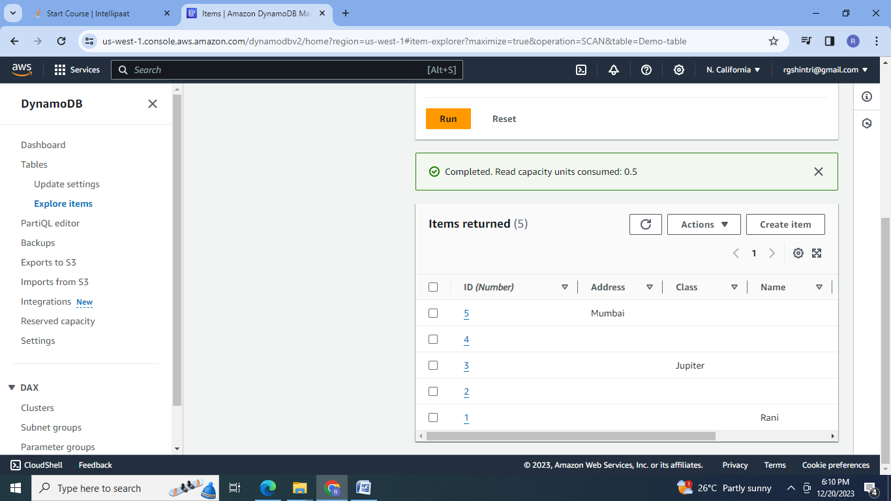

3. Take backup and delete the table

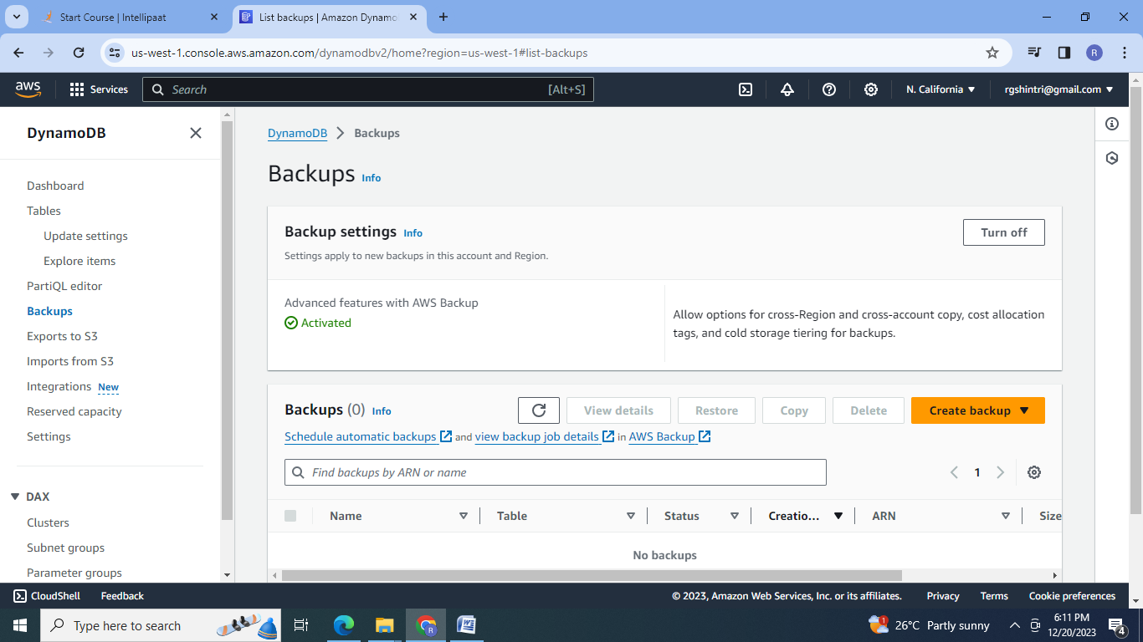

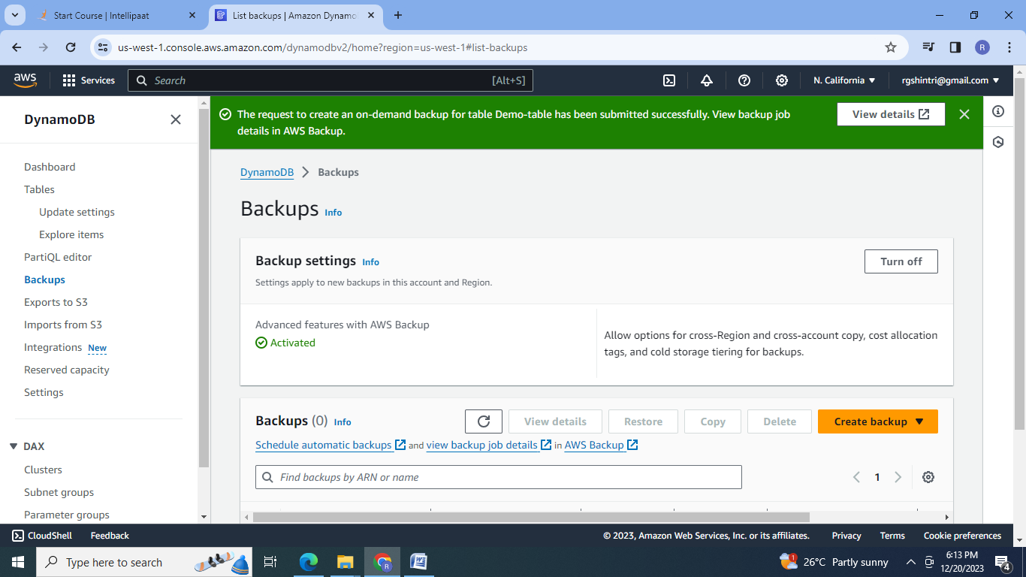

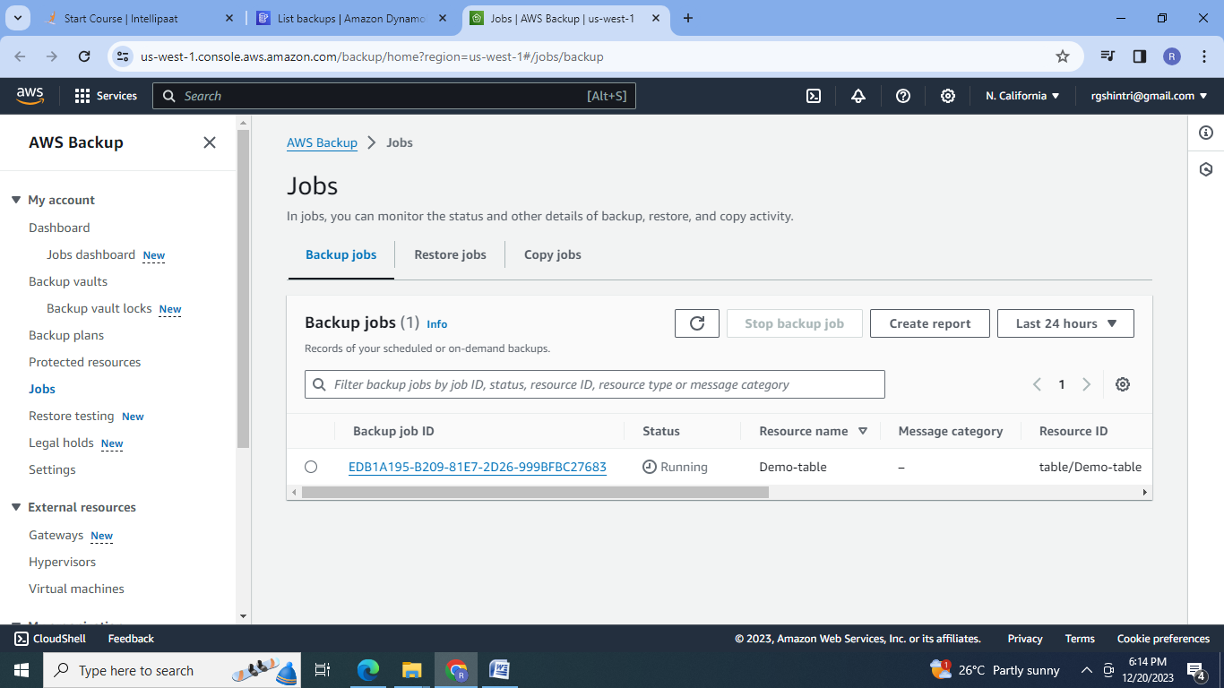

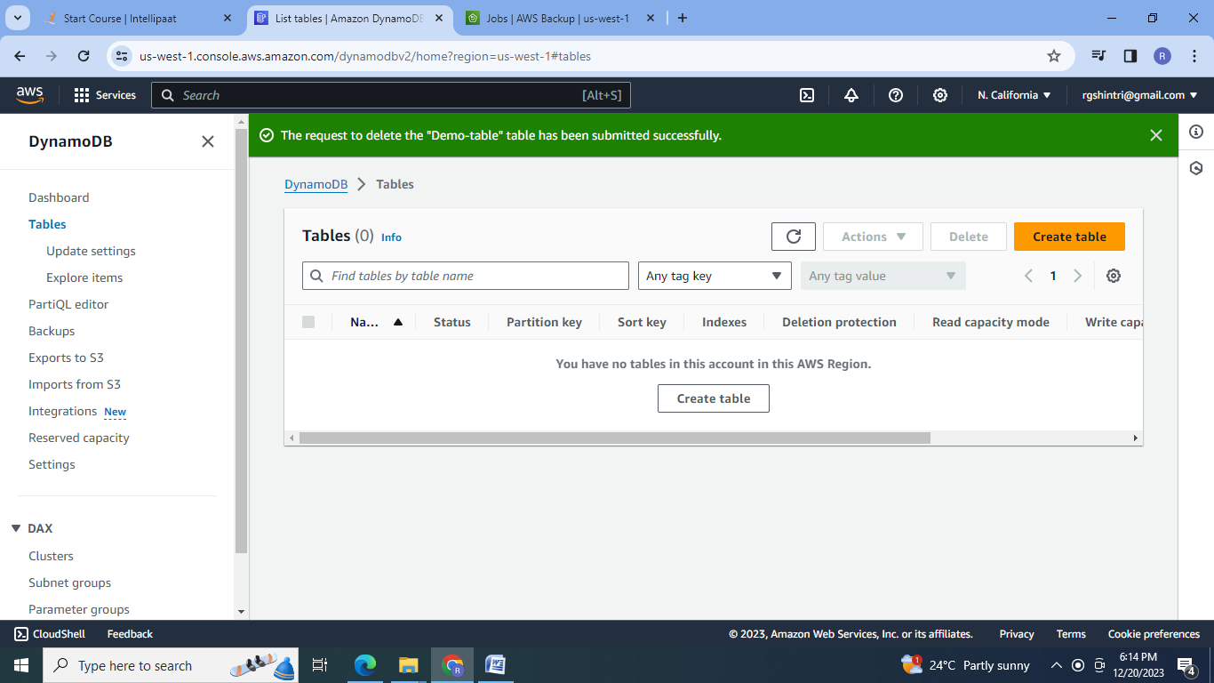

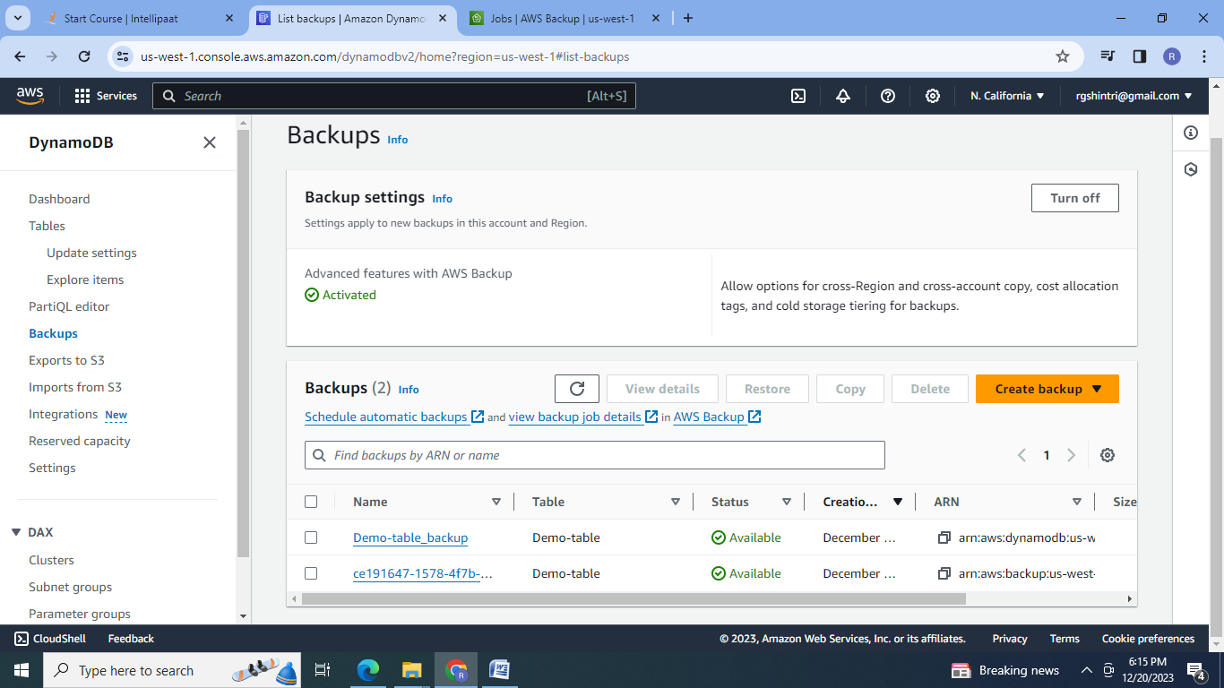

4.Restore from backup:

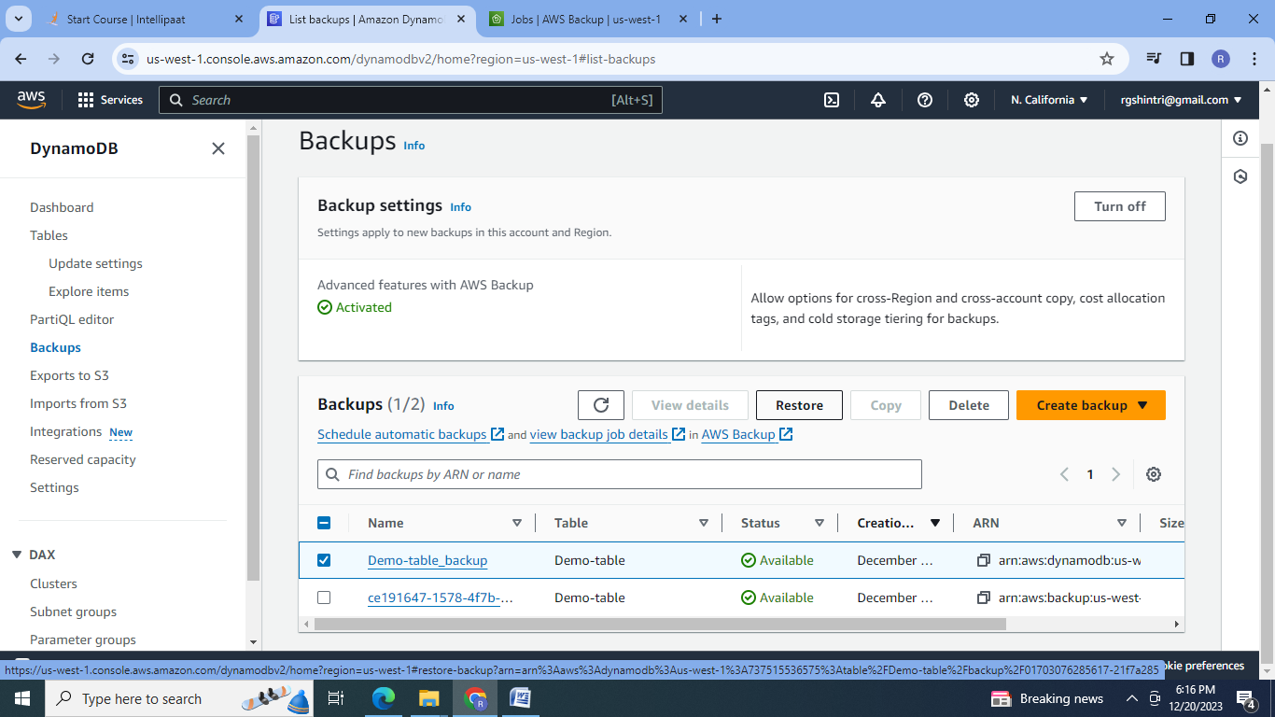

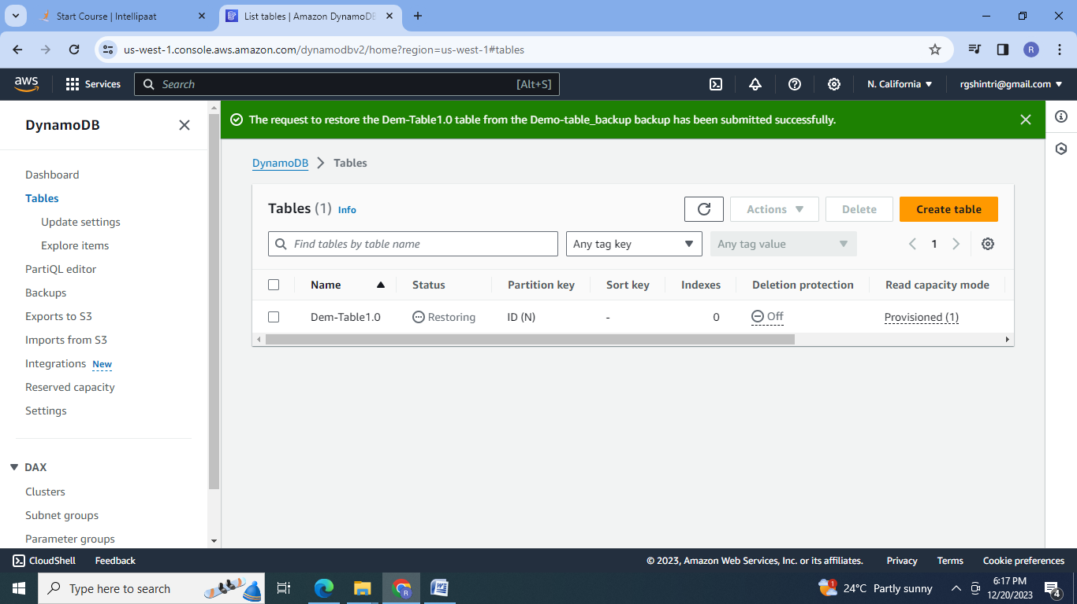

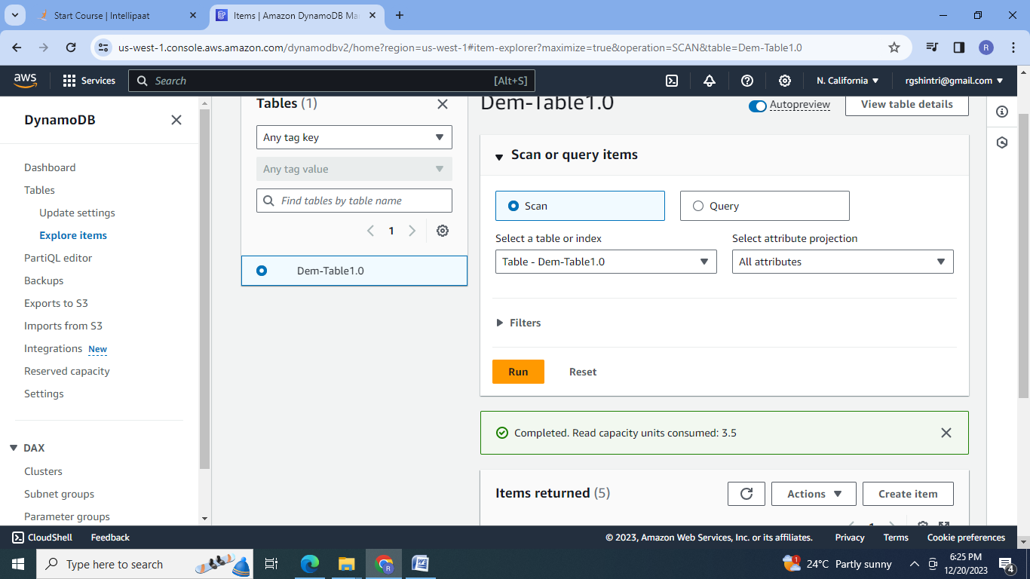

**D]** 1. Create a Redshift data warehouse.

1.Create S3 bucket

2.Load CSV file in the S3bucket:

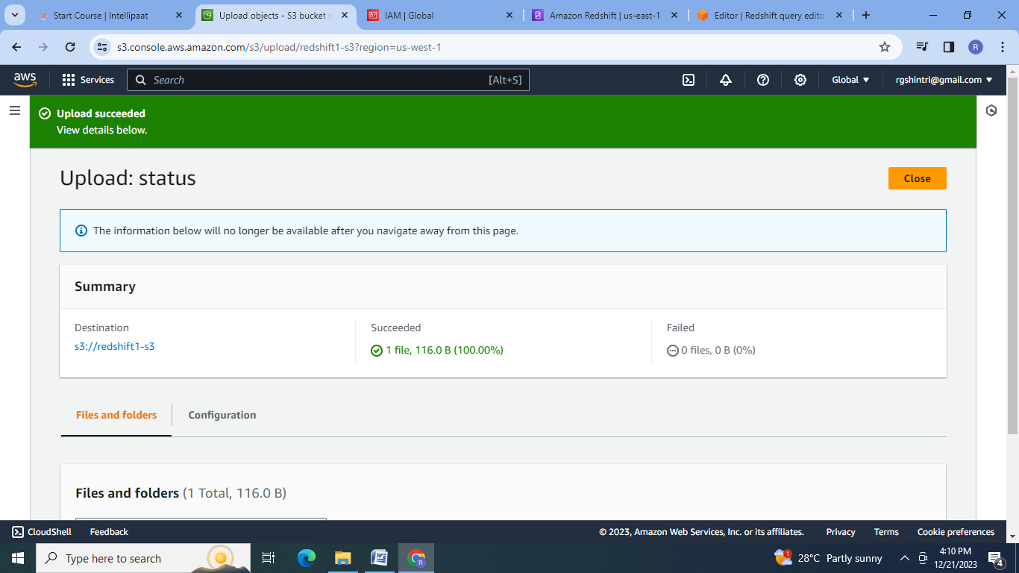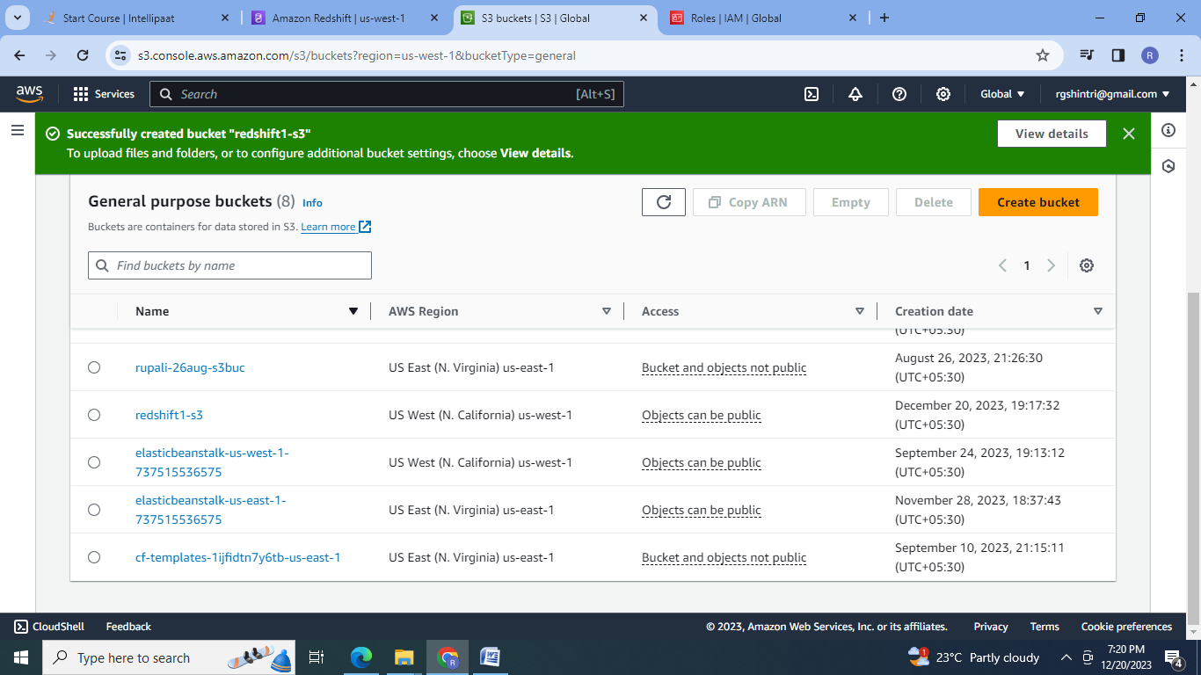

3.Create IAM role:

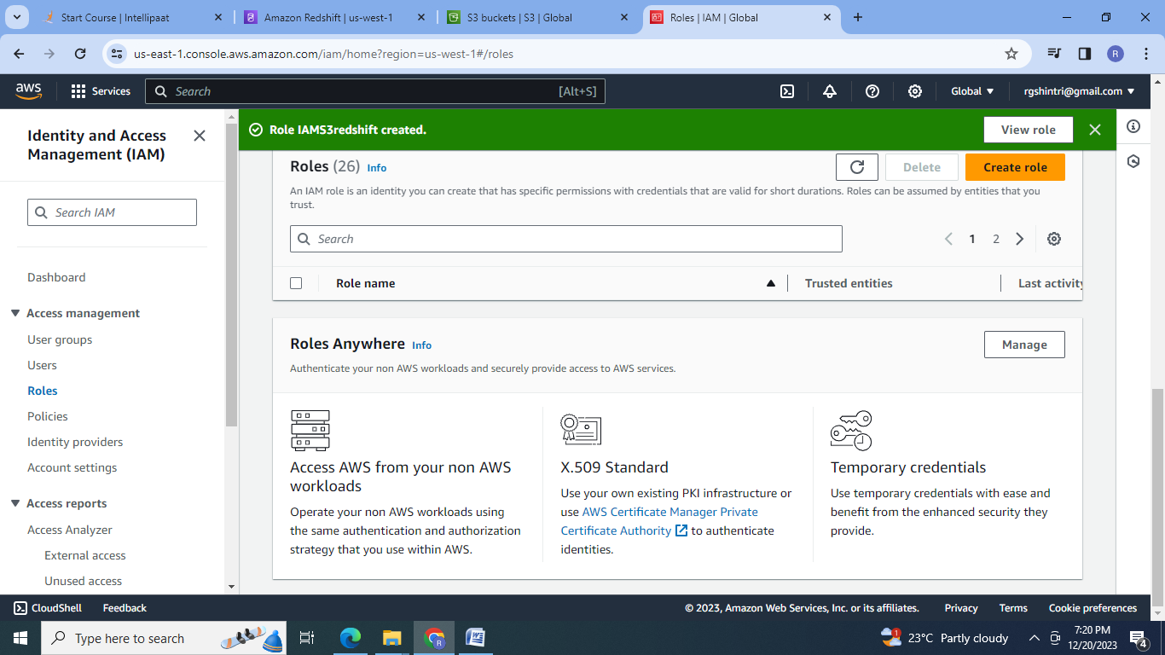

4.Create RedShift Cluster:

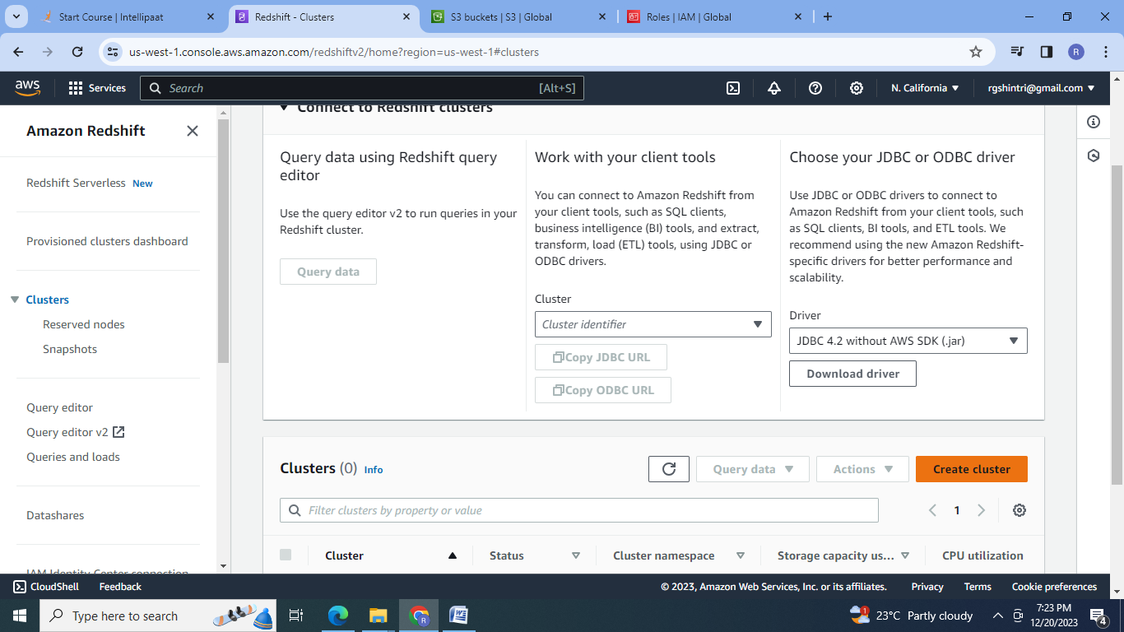

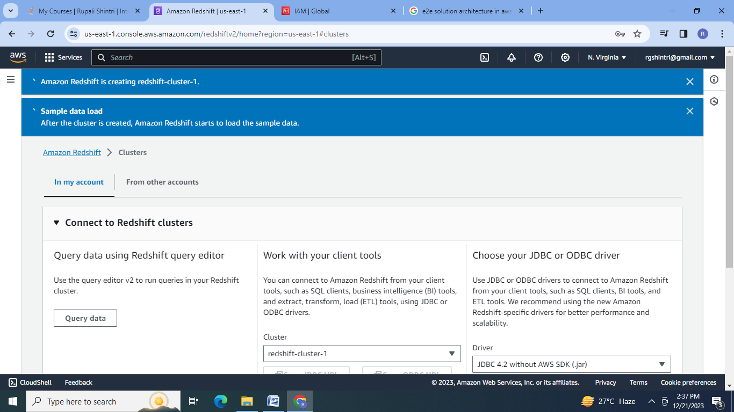

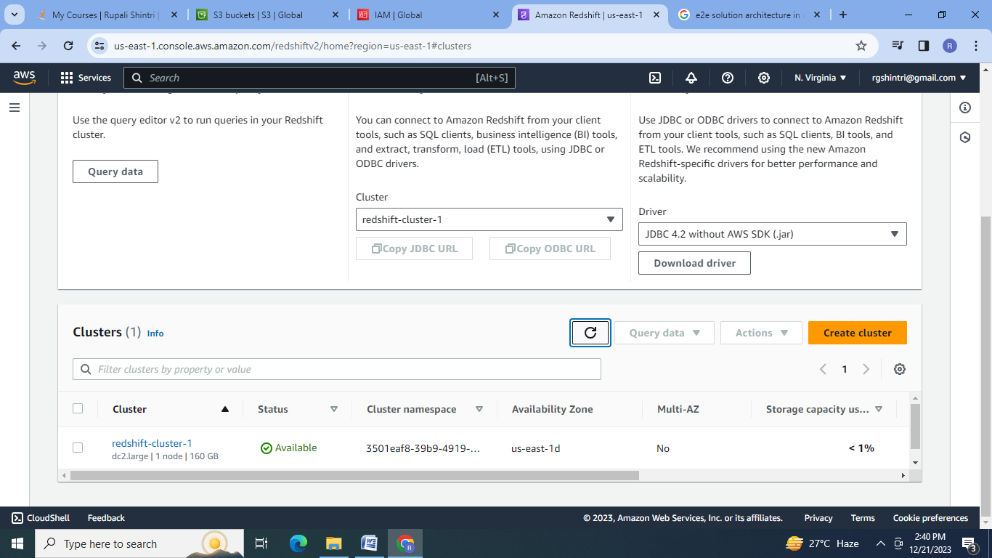

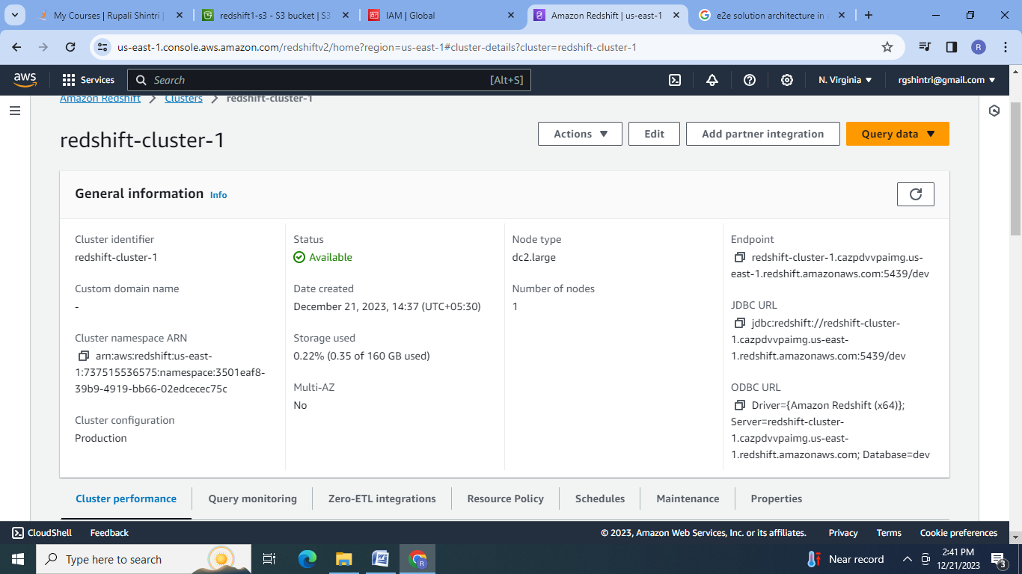

5.Open Query editor2:Create cluster & database connection :

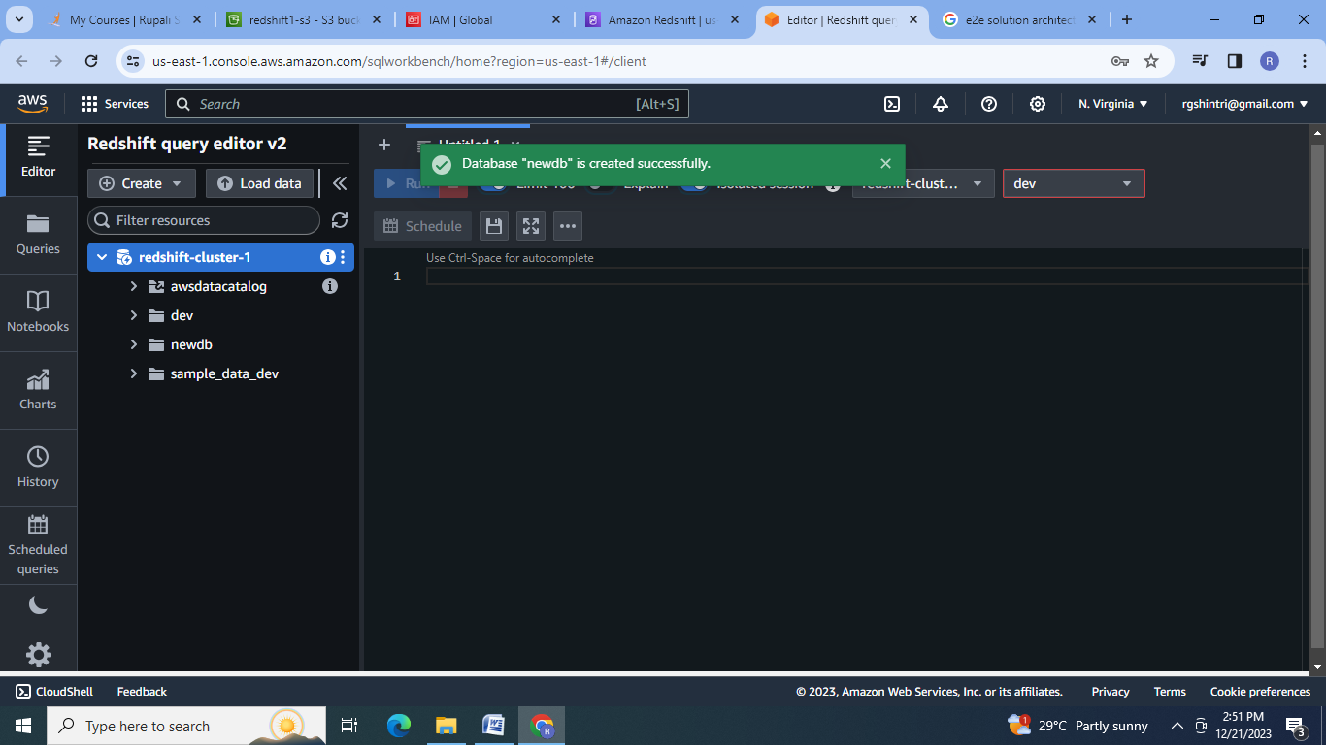

6.Load data

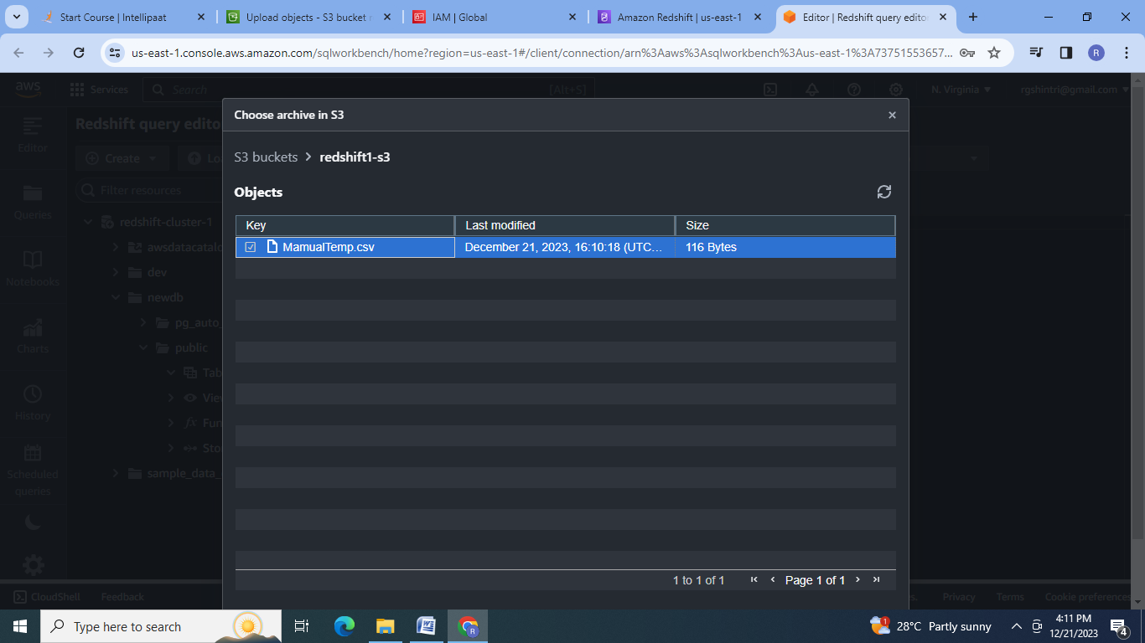

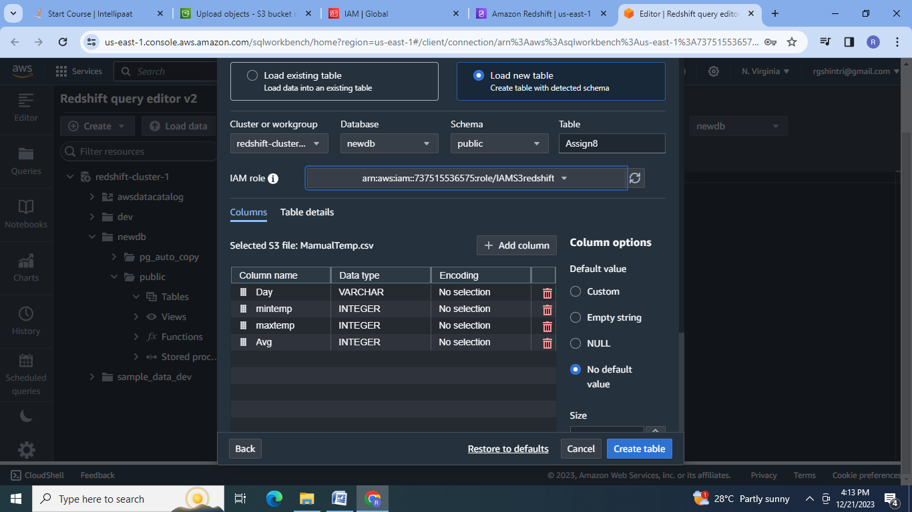

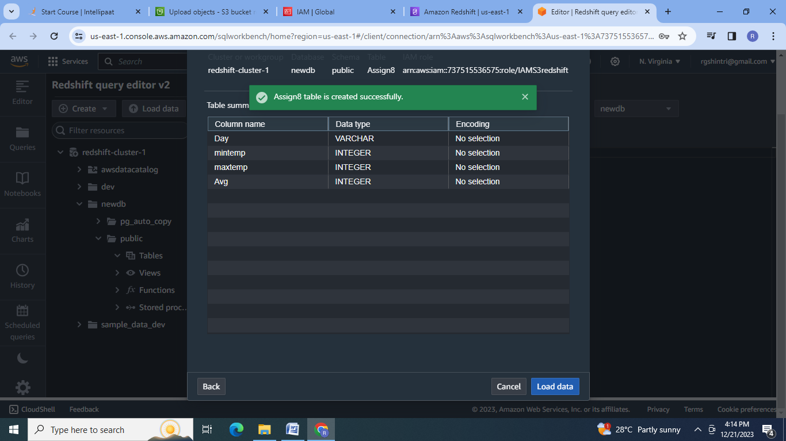

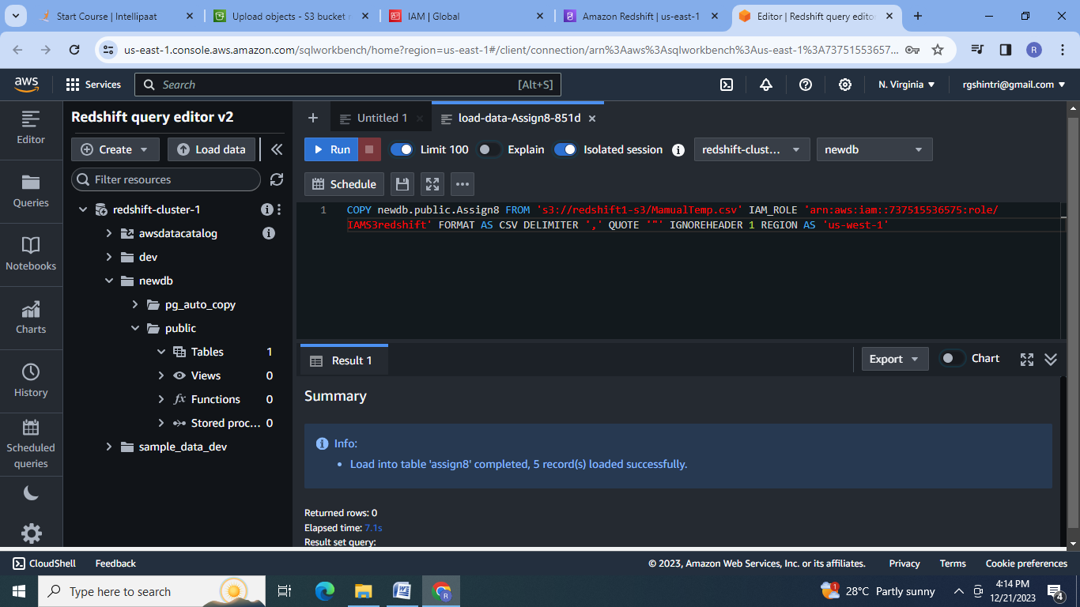

7.Query the data:

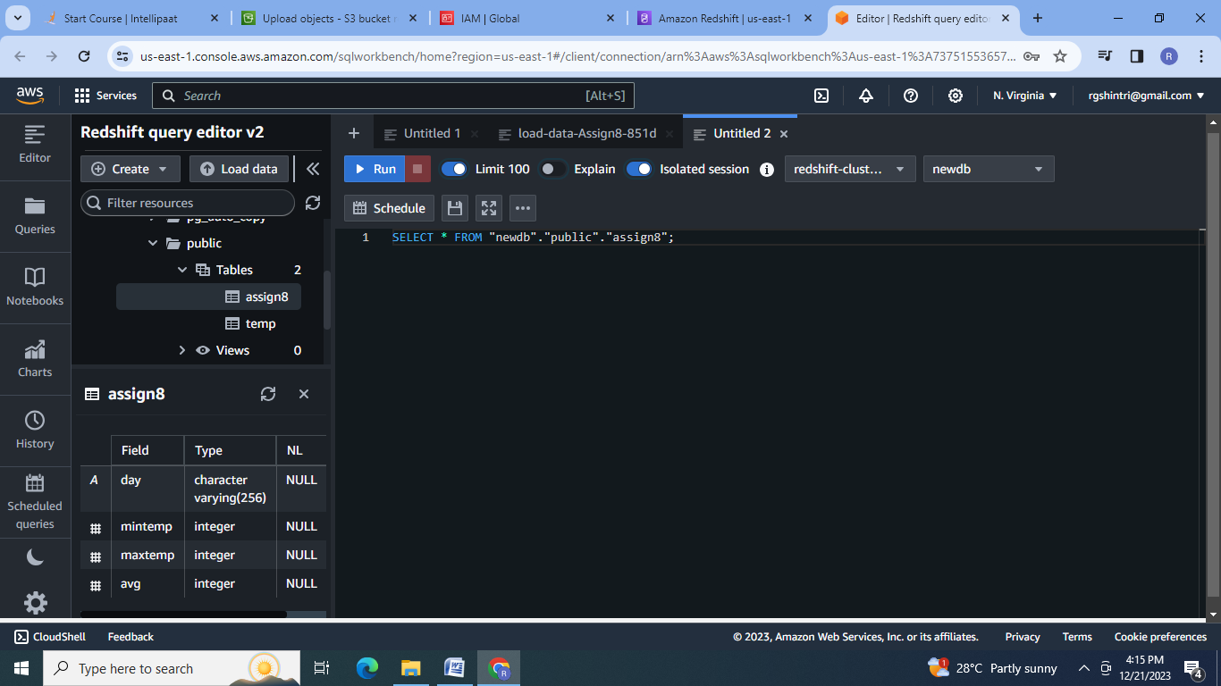

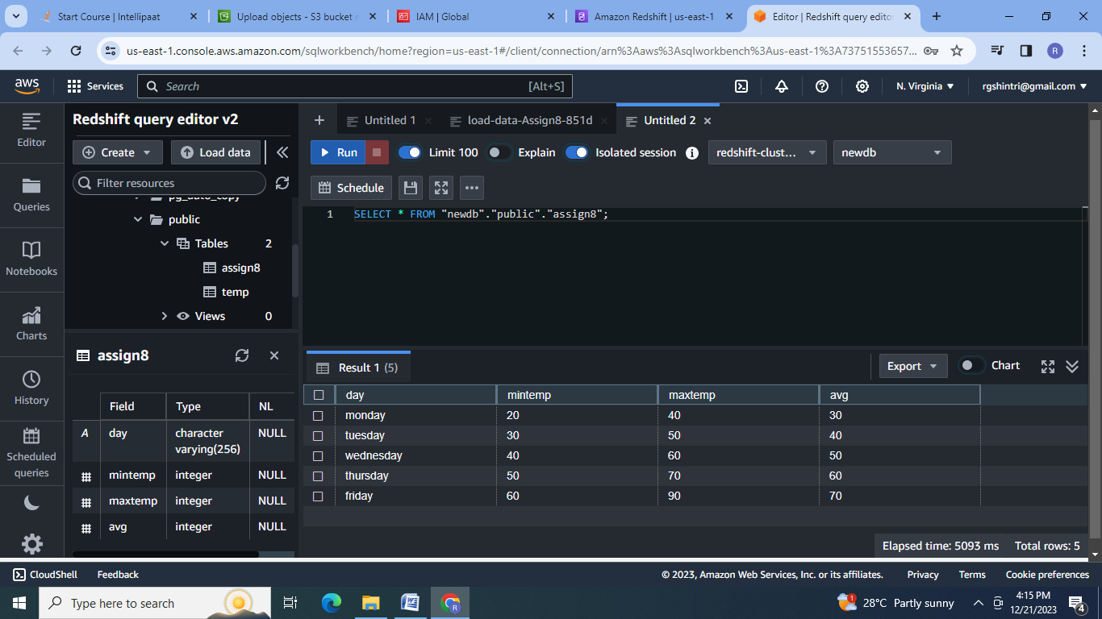

**Conclusion:** AWS provides the different relational & non-relational databases like RDS, DynamoDB, Redshift to fulfill the client requirements in easy & cost effective manner.

